

**BHARATIYA VIDYA BHAVAN’S SARDAR PATEL INSTITUTE OF TECHNOLOGY**

**(**Empowered Autonomous Institute Affiliated to Mumbai University)

**Department Of Computer Engineering**

|  |  |
| --- | --- |
| **Name** | Manish Shashikant Jadhav |
| **UID** | 2023301005 |
| **Subject** | Computer Communication and Networks (CCN) |
| **Experiment No.** | 09 |
| **Aim** | Experiment using Cisco Packet Tracer |
| **Implementation** |  |



**BHARATIYA VIDYA BHAVAN’S SARDAR PATEL INSTITUTE OF TECHNOLOGY**

**(**Empowered Autonomous Institute Affiliated to Mumbai University)

**Department Of Computer Engineering**

|  |  |
| --- | --- |
|  |  |

Task 1: Subnet the Address Space

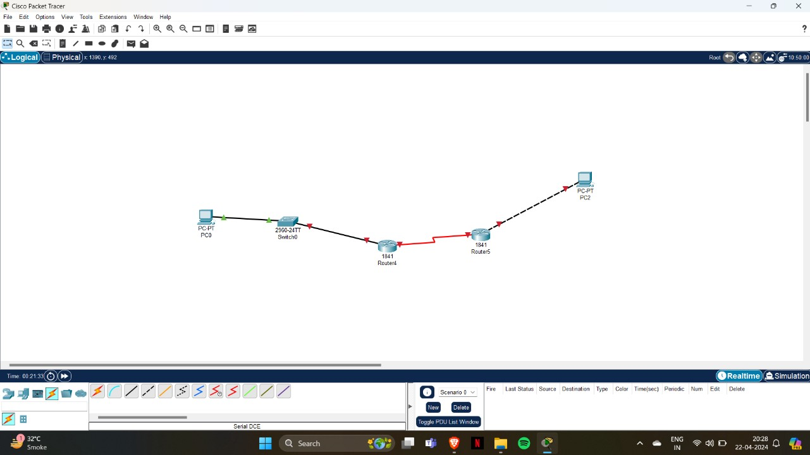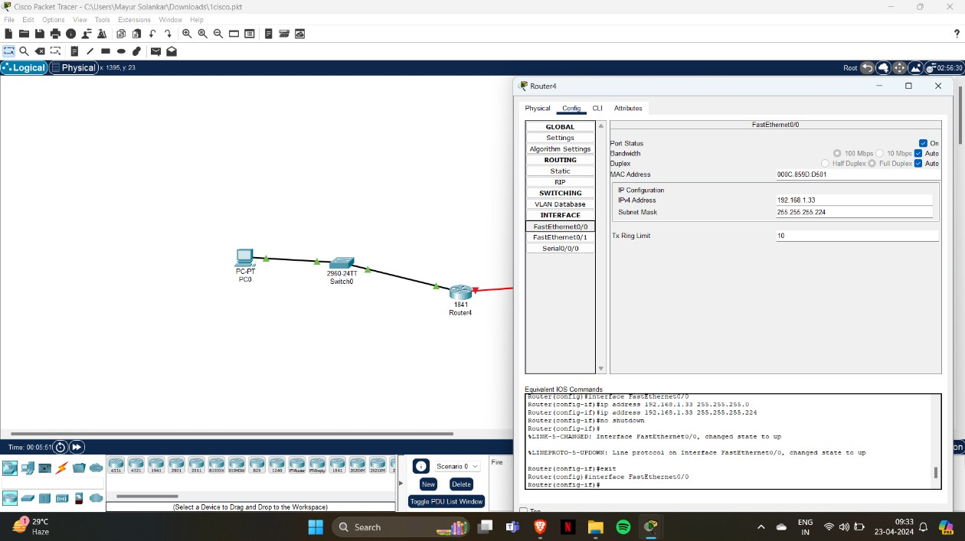

Task 2: Determine Interface Addresses.

Step 1: Assign appropriate addresses to the device interfaces.

1. Assign the first valid host address in subnet 1 to the LAN interface on R1 i.e., 192.168.1.33

Assign the last valid host address in subnet 1 to PC1 i.e., 192.168.1.62

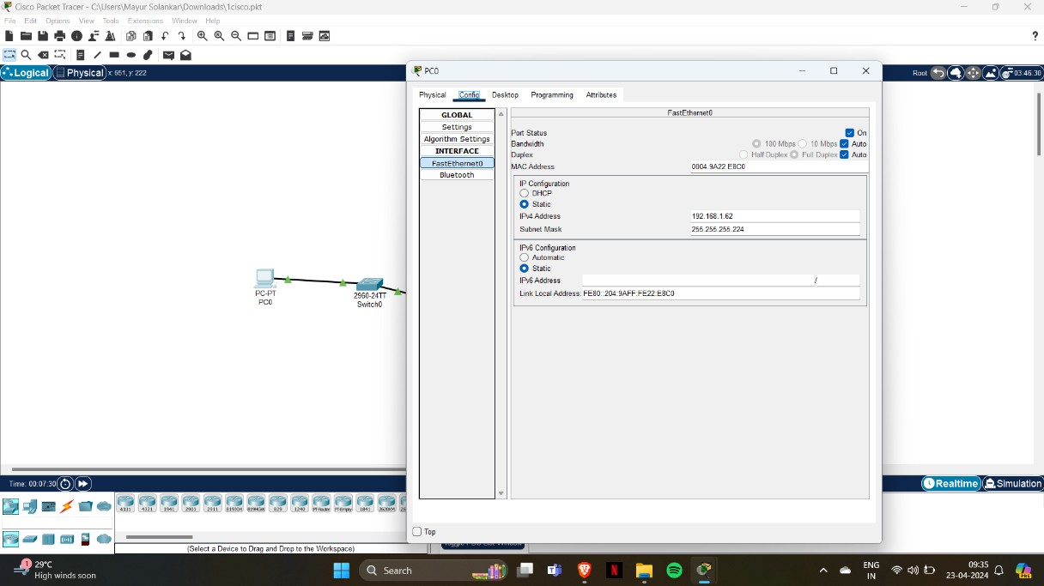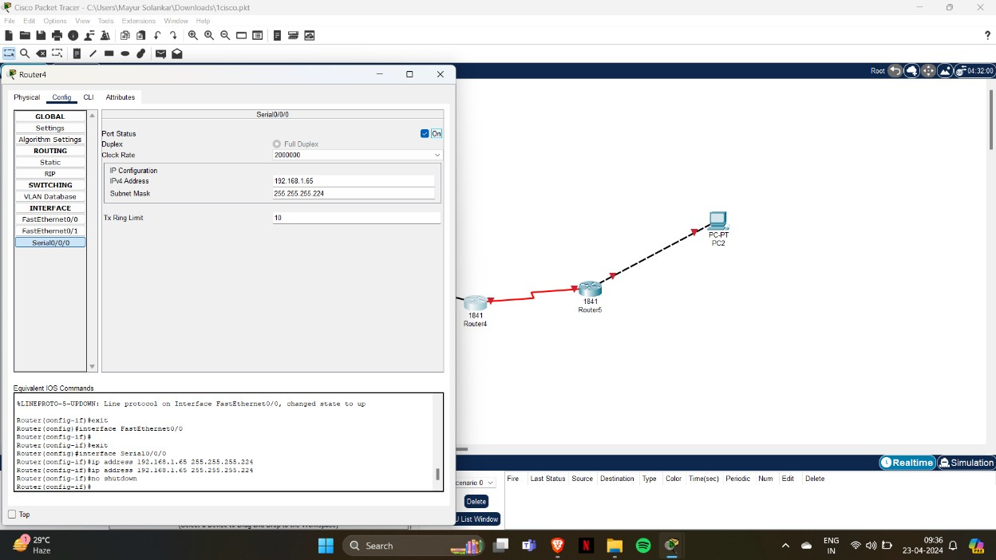

Assign the first valid host address in subnet 2 to the WAN interface on R1 i.e., 192.168.1.654

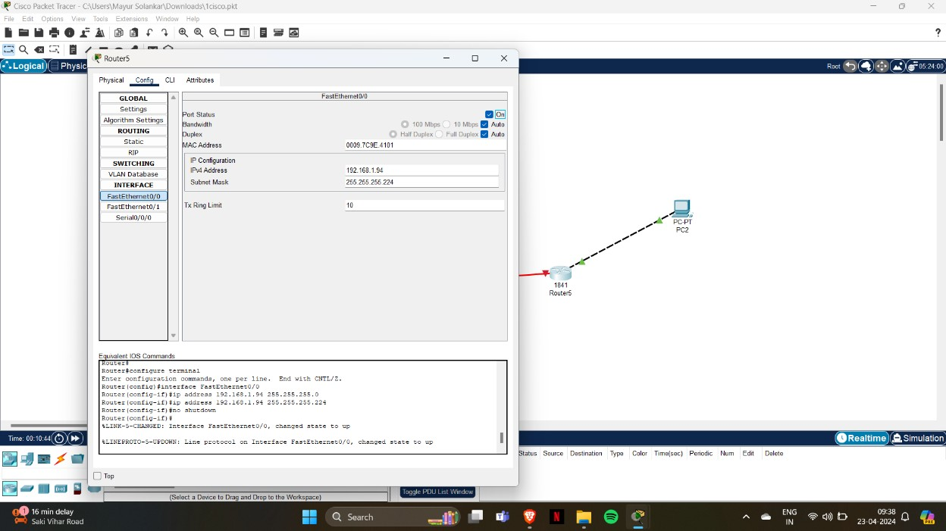

Assign the first valid host address in subnet 3 to the LAN interface of R2 i.e.,

192.168.1.97

Assign the last valid host address in subnet 2 to the WAN interface on R2 i.e.,

192.168.1.94

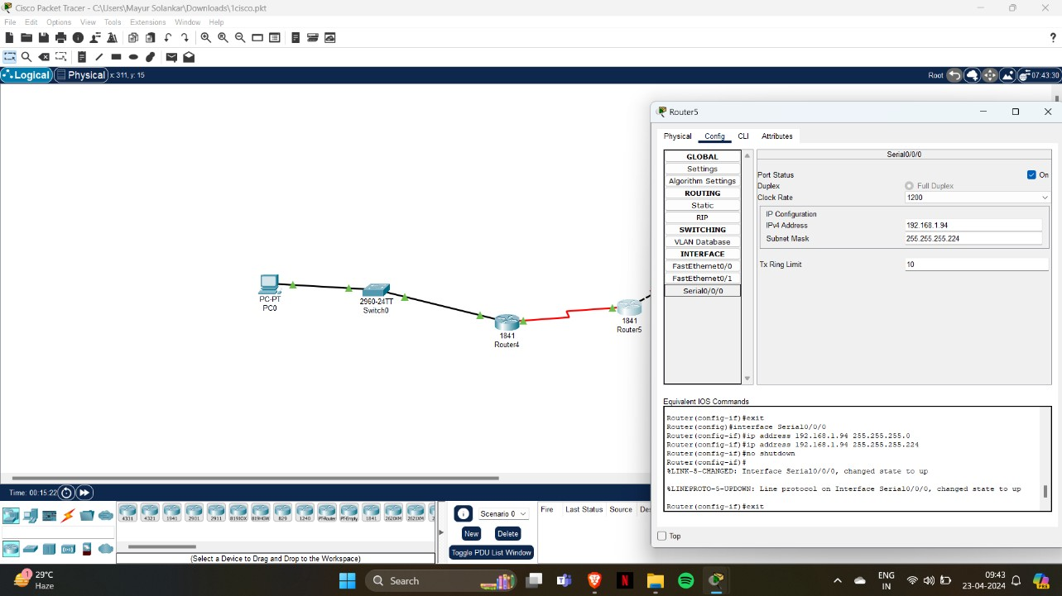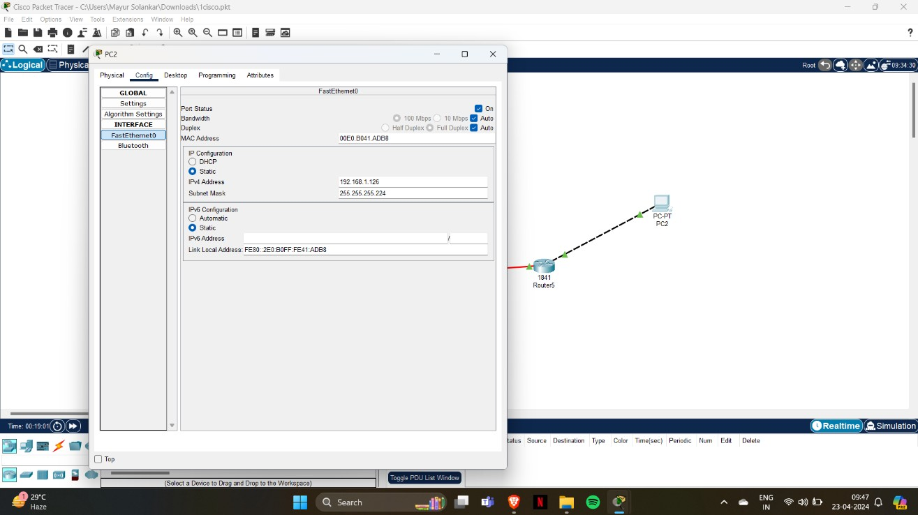

Assign the last valid host address in subnet 3 to PC2 i.e., 192.168.1.126

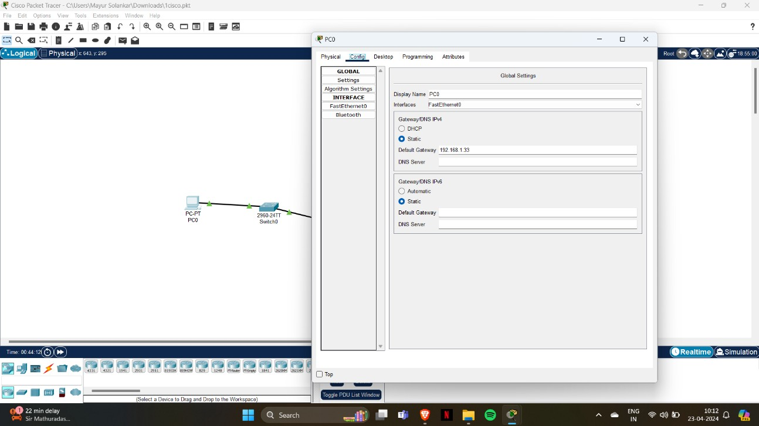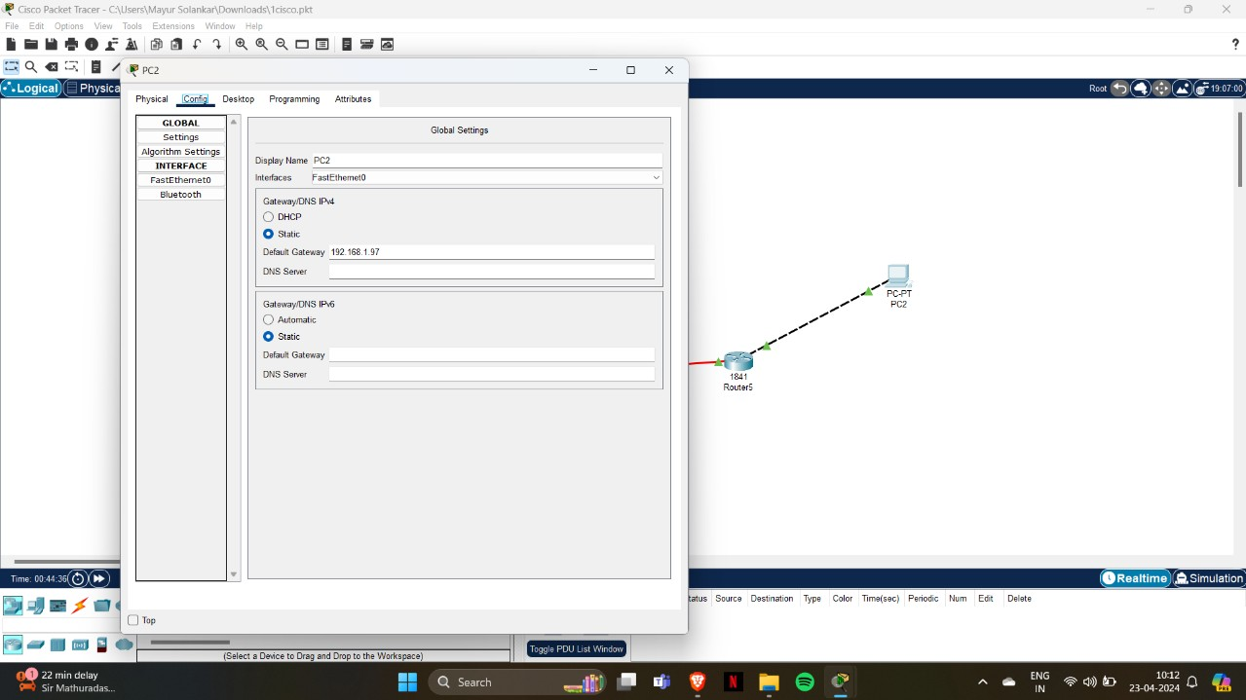

Task 3: Configure PC interfaces

Configure the Ethernet interfaces of PC1 and PC2 with the IP addresses and default gateways from your network design PC1 has the default gateway of 192.168.1.33 which is the LAN address of R1

PC1 has the default gateway of 192.168.1.97 which is the LAN address of R2

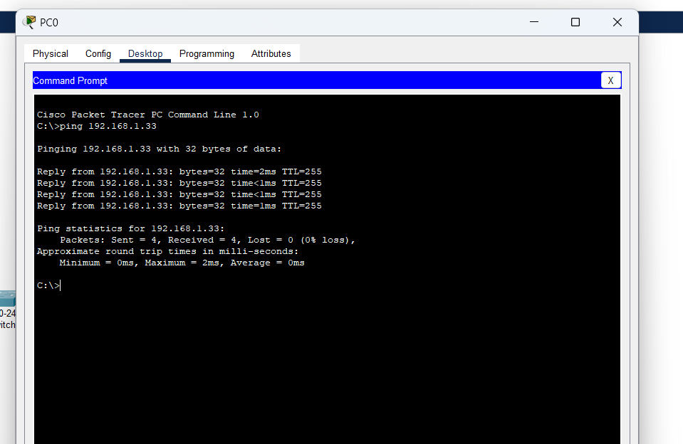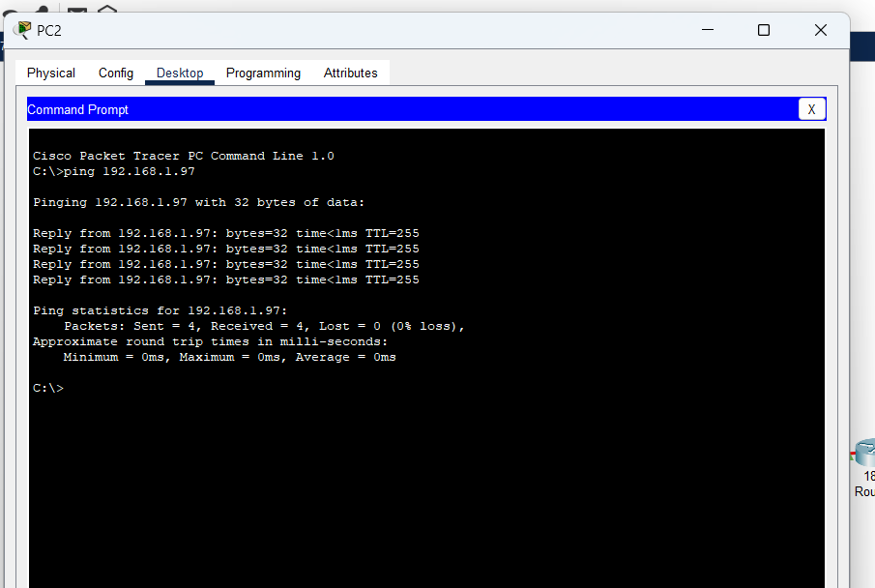

Please

attached screenshots to justify your answer.

1. From the host attached to R1, is it possible to ping the default gateway?
2. From the host attached to R2, is it possible to ping the default gateway?



**BHARATIYA VIDYA BHAVAN’S SARDAR PATEL INSTITUTE OF TECHNOLOGY**

**(**Empowered Autonomous Institute Affiliated to Mumbai University)

**Department Of Computer Engineering**

|  |  |
| --- | --- |
| **Conclusion** | Hence by completing this experiment I came to know about Cisco Packet Tracer. |